Marine Coordination Procedure
Harrow Bay Offshore Wind
Elena Márquez · 12 August 2026 · HB-CON-PRC-0007

1. Purpose
This procedure defines how vessel movements, safety zones and simultaneous operations (SIMOPS) are coordinated for the Harrow Bay construction site. It applies to all vessels working for Weyland and its contractors within the wind farm area, the export cable corridor and the Port of Eastholm approaches.

2. Marine Coordination Centre (MCC)
The MCC is located in the Weyland site office at the Port of Eastholm and is manned 24/7 during offshore operations. It is led by the Marine Coordinator, Ingrid Solberg, with four marine coordinators on 12-hour shifts.
- VHF channel 72 (working) and channel 16 (distress)
- Telephone +44 1632 960 455
- Vessel tracking via AIS and the marine coordination software
- Daily 17:00 SIMOPS call with all vessel masters
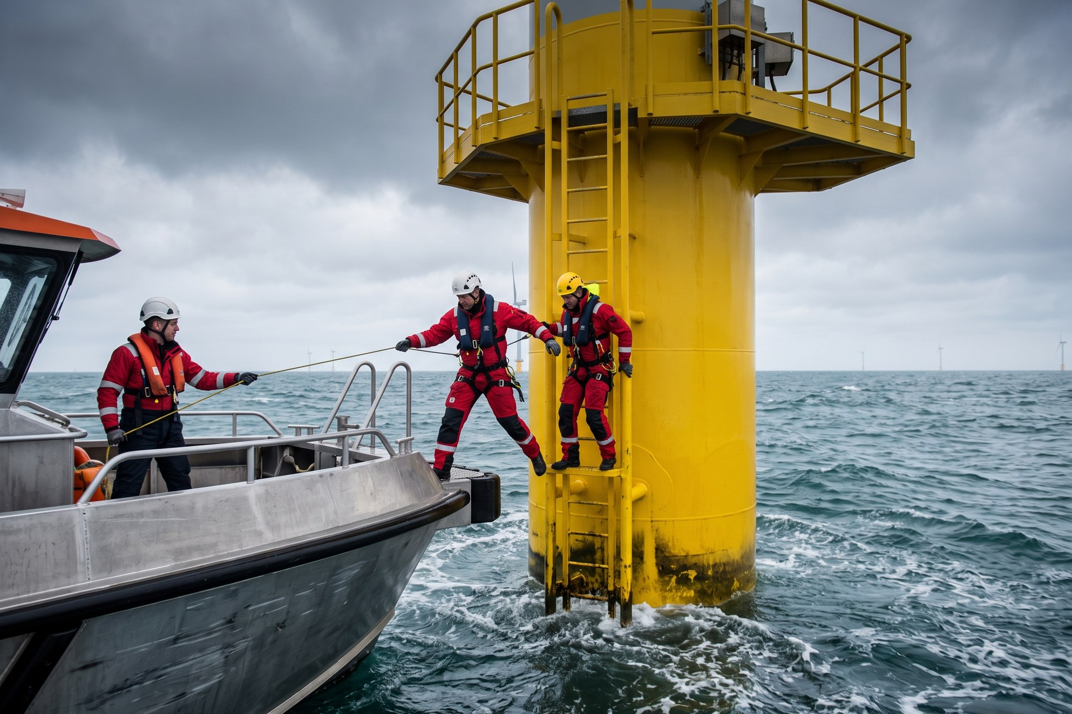
Crew transfer to a transition piece – bow transfer limit Hs 1.5 m

3. Vessel entry and access
Requirement | Details
Pre-entry | Vessel approval (audit, insurance, crew certificates) before first entry
Entry request | Call MCC on VHF 72 at 2 nm from the site boundary
Safety zones | 500 m around every installation vessel and structure under construction
CTV transfer limits | Hs ≤ 1.5 m bow transfer; ≤ 2.5 m walk-to-work
Personnel tracking | All persons logged in and out of structures via MCC

4. SIMOPS
Where two or more activities overlap in space or time (for example piling at HB-A12 while the offshore substation topside was lifted on 19 August 2026), a SIMOPS plan is issued at least 72 hours in advance and approved by the Offshore Construction Manager, Felix Brandt.

5. Weather limits
Activity | Hs limit | Wind limit (10 min mean)
Jack-up / jack-down MV Sea Atlas | 2.5 m | 15 m/s
Monopile upending and lifting | 2.0 m (jacked) | 15 m/s
TP lifting | – | 13 m/s
CTV transfer | 1.5 m | –
Bubble curtain deployment | 1.8 m | 12 m/s

6. Notices to Mariners
Notices to Mariners are issued weekly every Friday by the MCC and distributed to the Harbour Master, the Coastguard, the Fisheries Liaison Officer and the local fishing associations.

